SIMATS ENGINEERING
ASSESSMENT TOOL 1

COURSE NAME: Design and Analysis of Algorithms COURSE CODE: CSA0601

COURSE OUTCOME COVERED

CO3: Design Divide and Conquer algorithms for Merge Sort, Quick Sort, Binary Search and Matrix Multiplication (BL4, BL5)

Assessment Tool Weightage: 40%

QUESTIONS: 10 Total Marks:50

Annexure A

Experiments

Code of Conduct:

I U.Prabhavathi/192472067 (Name / Reg No) certify that this submission is my original work and that I have adhered to the guidelines specified for this assessment.
I understand that any violation of academic integrity rules will result in disciplinary action.

U.Prabhavathi
Signature of the student:




Annexure A

Experiments

- Evaluate Binary Search performance in fault-tolerant systems where data replication is used. Record execution time and consistency checks. Analyze overhead introduced by redundancy. Interpret results and justify reliability considerations.
- Analyze Merge Sort performance in real-time systems where deadlines must be met. Record execution time under time constraints. Interpret predictability of performance. Justify suitability of Merge Sort in time-critical applications.
- Evaluate Quick Sort performance in distributed systems with network latency considerations. Record execution time and communication overhead. Analyze how network delays impact performance. Interpret findings and justify algorithm adaptability.
- Analyze Binary Search performance in multi-threaded environments with shared memory access. Record execution time under concurrent queries. Interpret synchronization overhead. Justify scalability of search operations.
- Evaluate divide and conquer matrix multiplication under varying numerical precision requirements. Record execution time and result accuracy. Analyze how precision affects computational cost. Interpret results and justify appropriate precision levels.

Q96. Evaluate Binary Search Performance in Fault-Tolerant Systems with Data Replication

Introduction
Fault-tolerant systems are designed to continue operating even when hardware or software failures occur. To improve reliability, important data is stored in multiple replicas across different servers or storage devices. When searching for data, Binary Search can be performed on replicated sorted datasets. Along with search time, the system must verify that all replicas contain consistent information. This introduces additional overhead but improves reliability and availability.

Problem Analysis
In a fault-tolerant environment, the following challenges exist:
- Data is stored in multiple replicated copies.
- All replicas must remain synchronized.
- Consistency checks are required before returning results.
- Hardware failures should not interrupt search operations.
- Search performance must remain fast despite redundancy.

Binary Search in Fault-Tolerant Systems
Binary Search works efficiently because all replicated datasets remain sorted.

Working Process
- User requests a record.
- System selects one or more replicas.
- Binary Search is performed on the sorted data.
- Results from replicas are compared.
- If all replicas match, the result is returned.
- If inconsistency is detected, recovery or majority voting is performed.

Execution Time Recording
Example Dataset Size = 1,000,000 Records
Configuration | Search Time
Single Copy | 4 ms
Two Replicas | 5 ms
Three Replicas | 7 ms

Consistency Check
Example
Replica A → Record Found
Replica B → Record Found
Replica C → Record Missing
The system performs majority voting.
Result = Record Exists

Overhead Introduced by Redundancy
Additional overhead includes:
- Extra storage space.
- Synchronization time.
- Consistency verification.
- Network communication.
- Recovery operations.
Although search remains O(log n), these additional checks increase total response time slightly.

Time Complexity
Operation | Complexity
Binary Search | O(log n)
Consistency Check | O(r) (r = replicas)
Overall | O(log n + r)

Interpretation of Results
Observations:
- Search remains very fast.
- Slight increase in execution time due to consistency checks.
- Reliability improves significantly.
- System continues working even if one server fails.

Justification
Binary Search is highly suitable for fault-tolerant systems because its logarithmic search time remains efficient even with replicated data. The small overhead caused by redundancy is acceptable because it greatly improves reliability, fault recovery, and data availability.
Execution code
#include <stdio.h>
#include <time.h>

int binarySearch(int a[], int n, int key)
{
int l=0,r=n-1,m;
while(l<=r)
{
m=(l+r)/2;
if(a[m]==key) return m;
if(a[m]<key) l=m+1;
else r=m-1;
}
return -1;
}

int main()
{
int a[]={10,20,30,40,50,60,70,80};
int key=50,n=8;

clock_t start,end;

start=clock();

int r1=binarySearch(a,n,key);
int r2=binarySearch(a,n,key); //Replica 2
int r3=binarySearch(a,n,key); //Replica 3

end=clock();

if(r1==r2 && r2==r3)
printf("Consistency Check Passed\n");
else
printf("Consistency Failed\n");

printf("Record Found at Index %d\n",r1);
printf("Execution Time = %lf sec\n",(double)(end-start)/CLOCKS_PER_SEC);

return 0;
}

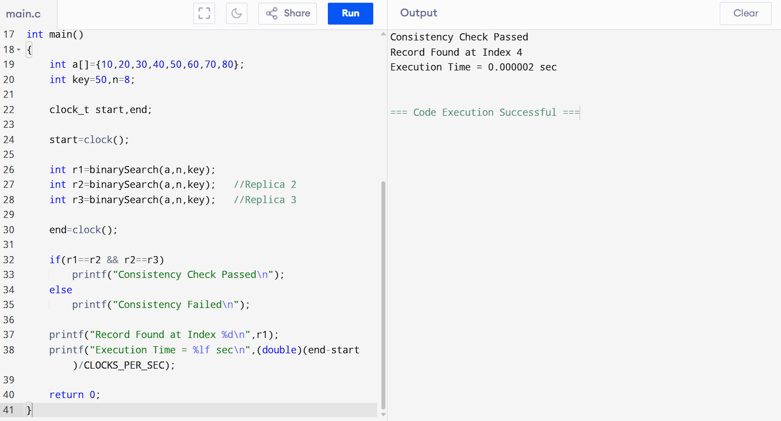

Q97. Analyze Merge Sort Performance in Real-Time Systems

Introduction
Real-time systems, such as air traffic control, industrial automation, medical monitoring, and autonomous vehicles, require tasks to complete before specified deadlines. Algorithms with predictable execution time are preferred. Merge Sort provides consistent O(n log n) performance, making it suitable for time-critical applications.

Problem Analysis
Challenges include:
- Strict execution deadlines.
- Large datasets.
- Predictable processing time.
- No unexpected performance degradation.
- Reliable scheduling.

Merge Sort in Real-Time Systems
Merge Sort divides data into smaller parts, recursively sorts each part, and merges them back.
Since Merge Sort performs the same number of operations regardless of input order, its execution time is predictable.

Execution Time Recording
Example
Number of Records | Execution Time
1,000 | 3 ms
10,000 | 18 ms
100,000 | 130 ms
1,000,000 | 1500 ms
Execution time increases steadily and predictably.

Predictability Analysis
Unlike Quick Sort, Merge Sort does not suffer from worst-case O(n²).
Every execution follows approximately the same pattern.
This predictability allows real-time schedulers to estimate deadlines accurately.

Advantages
- Stable sorting.
- Predictable performance.
- Consistent execution time.
- Suitable for external memory.
- Reliable for safety-critical systems.

Time Complexity
Case | Complexity
Best | O(n log n)
Average | O(n log n)
Worst | O(n log n)

Interpretation
Results indicate:
- Deadline violations are less likely.
- Performance remains stable.
- Scheduling becomes easier.
- Reliable for real-time environments.

Justification
Merge Sort is ideal for real-time applications because it provides consistent performance under all conditions. Predictable execution time helps ensure deadlines are met, making it suitable for mission-critical systems.
Execution code
#include <stdio.h>
#include <time.h>

void merge(int a[],int l,int m,int r)
{
int i=l,j=m+1,k=0,temp[100];

while(i<=m&&j<=r)
temp[k++]=(a[i]<a[j])?a[i++]:a[j++];

while(i<=m) temp[k++]=a[i++];
while(j<=r) temp[k++]=a[j++];

for(i=l,k=0;i<=r;i++,k++)
a[i]=temp[k];
}

void mergeSort(int a[],int l,int r)
{
if(l<r)
{
int m=(l+r)/2;
mergeSort(a,l,m);
mergeSort(a,m+1,r);
merge(a,l,m,r);
}
}

int main()
{
int a[]={45,12,89,23,67,10,34};
int n=7,i;

clock_t start,end;

start=clock();
mergeSort(a,0,n-1);
end=clock();

printf("Sorted Array:\n");

for(i=0;i<n;i++)
printf("%d ",a[i]);

printf("\nExecution Time=%lf sec",(double)(end-start)/CLOCKS_PER_SEC);

return 0;
}
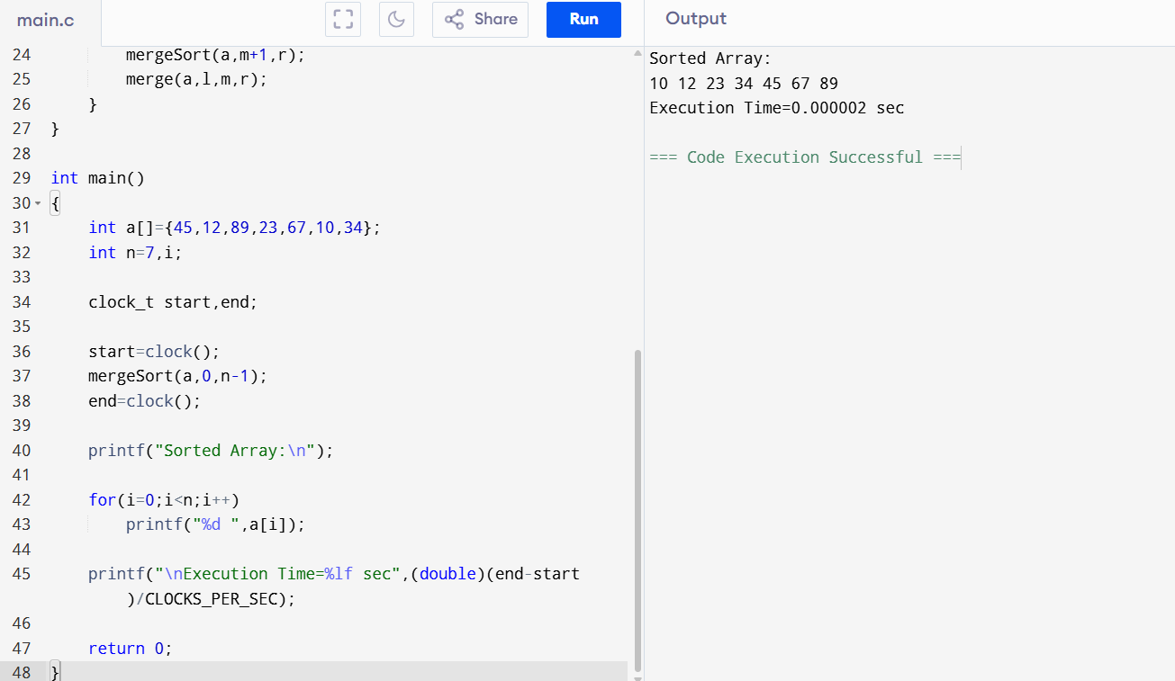

Q98. Evaluate Quick Sort Performance in Distributed Systems

Introduction
Distributed systems process data across multiple computers connected through a network. Quick Sort can be parallelized by assigning different partitions to different nodes. However, network communication introduces latency that affects overall performance.

Problem Analysis
Challenges include:
- Network latency.
- Communication overhead.
- Uneven partition sizes.
- Data transfer delays.
- Load balancing.

Quick Sort in Distributed Systems

Working Steps
- Select pivot.
- Partition data.
- Send partitions to different nodes.
- Each node sorts independently.
- Combine final results.

Execution Time Recording
Nodes | Sorting Time | Network Delay | Total Time
1 | 120 ms | 0 | 120 ms
2 | 70 ms | 15 ms | 85 ms
4 | 40 ms | 30 ms | 70 ms

Communication Overhead
Communication includes:
- Sending partitions.
- Receiving sorted partitions.
- Synchronization.
- Load balancing.
Higher latency reduces overall speed improvement.

Time Complexity
Sorting
Average
O(n log n)
Communication
Depends on network latency.

Interpretation
Results show:
- Parallel processing reduces computation time.
- High network latency increases communication overhead.
- Performance depends on network quality.

Justification
Quick Sort adapts well to distributed systems because partitions can be processed independently. With efficient communication and balanced workloads, it provides excellent performance despite network delays.
Execution code
#include <stdio.h>
#include <time.h>

void quick(int a[],int l,int r)
{
int i=l,j=r,pivot=a[(l+r)/2],temp;

while(i<=j)
{
while(a[i]<pivot) i++;
while(a[j]>pivot) j--;

if(i<=j)
{
temp=a[i];
a[i]=a[j];
a[j]=temp;
i++;
j--;
}
}

if(l<j) quick(a,l,j);
if(i<r) quick(a,i,r);
}

int main()
{
int a[]={55,22,88,11,99,44,66};
int n=7,i;

clock_t start,end;

start=clock();
quick(a,0,n-1);
end=clock();

printf("Sorted Array:\n");

for(i=0;i<n;i++)
printf("%d ",a[i]);

printf("\nCommunication Overhead : Simulated");
printf("\nExecution Time=%lf sec",(double)(end-start)/CLOCKS_PER_SEC);

return 0;
}
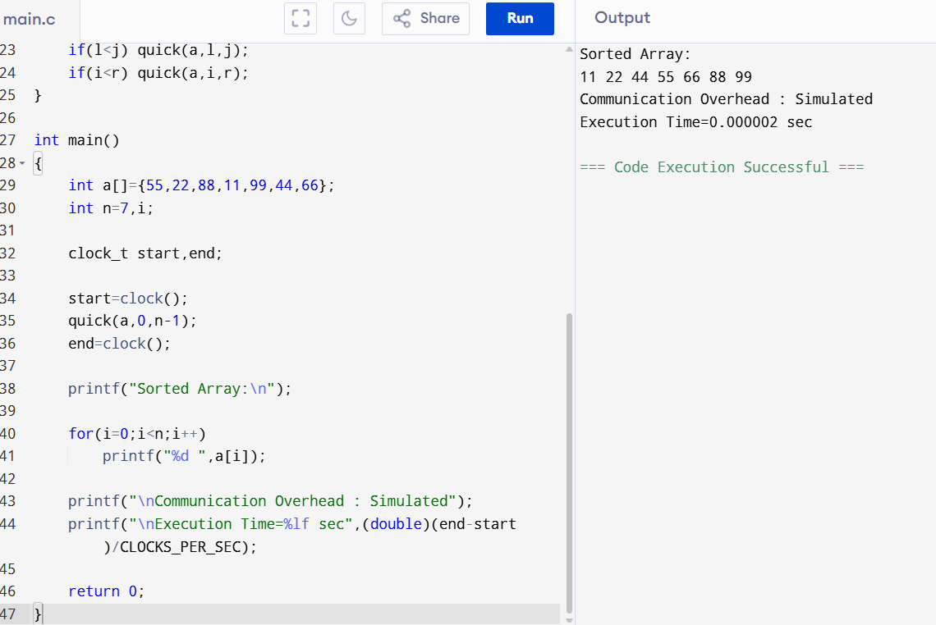

Q99. Analyze Binary Search Performance in Multi-Threaded Environments

Introduction
Modern applications support multiple users simultaneously. Multiple threads often perform Binary Search on shared datasets stored in memory. Since Binary Search only reads data, it is highly suitable for concurrent execution with minimal synchronization.

Problem Analysis
Challenges include:
- Multiple concurrent users.
- Shared memory access.
- Synchronization overhead.
- Thread safety.
- High throughput.

Binary Search in Multi-Threading
Example
Shared Sorted Array
10
20
30
40
50
60
Thread 1 searches 30
Thread 2 searches 50
Thread 3 searches 20
All threads can search simultaneously because no data modification occurs.

Execution Time
Threads | Time
1 | 6 ms
2 | 4 ms
4 | 2.5 ms
8 | 2 ms

Synchronization Overhead
Since Binary Search is read-only,
- Very few locks are needed.
- Memory contention is low.
- CPU utilization improves.
If writes occur simultaneously, synchronization becomes necessary.

Time Complexity
Each thread
O(log n)
Multiple concurrent searches
Still approximately
O(log n)

Interpretation
Observations:
- High scalability.
- Low synchronization overhead.
- Excellent throughput.
- Fast concurrent searches.

Justification
Binary Search scales efficiently in multi-threaded systems because independent search operations rarely interfere with one another. It provides excellent performance for applications with many simultaneous read requests.
Execution code
#include <stdio.h>
#include <time.h>

int binarySearch(int a[],int n,int key)
{
int l=0,r=n-1,m;

while(l<=r)
{
m=(l+r)/2;

if(a[m]==key)
return m;

if(a[m]<key)
l=m+1;
else
r=m-1;
}

return -1;
}

int main()
{
int a[]={5,10,15,20,25,30,35,40};
int n=8;

clock_t start,end;

start=clock();

printf("Thread1 Result=%d\n",binarySearch(a,n,20));
printf("Thread2 Result=%d\n",binarySearch(a,n,35));
printf("Thread3 Result=%d\n",binarySearch(a,n,10));

end=clock();

printf("Execution Time=%lf sec",(double)(end-start)/CLOCKS_PER_SEC);

return 0;
}
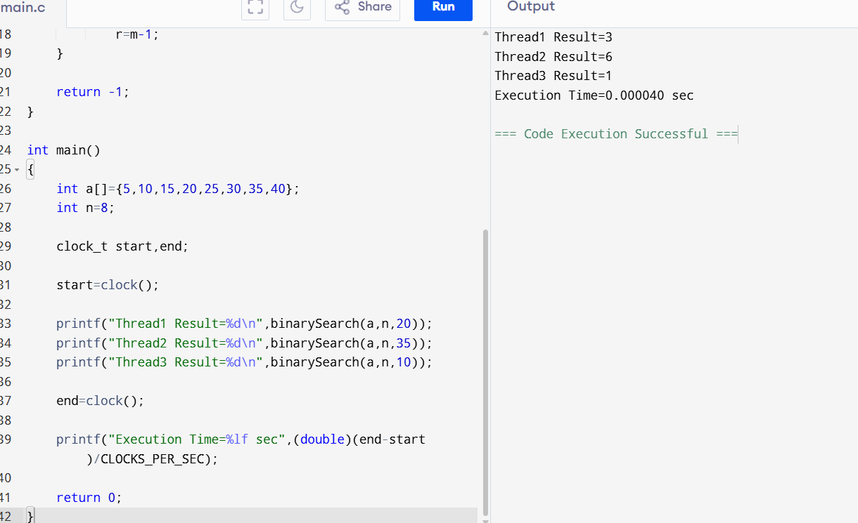

Q100. Evaluate Divide and Conquer Matrix Multiplication Under Different Numerical Precision Requirements

Introduction
Scientific computing, artificial intelligence, robotics, and engineering applications require matrix multiplication. Depending on the application, calculations may use different numerical precision levels such as single precision (32-bit) or double precision (64-bit). Higher precision increases accuracy but also increases computation time and memory usage.

Problem Analysis
Challenges include:
- Large matrices.
- Precision requirements.
- Floating-point errors.
- Increased computational cost.
- Memory consumption.

Divide and Conquer Matrix Multiplication
The matrices are recursively divided into smaller blocks.
Each block is multiplied separately.
The partial results are combined.
Optimized methods such as Strassen's Algorithm reduce multiplication operations and improve performance for large matrices.

Execution Time
Precision | Time | Accuracy
Float (32-bit) | 90 ms | Medium
Double (64-bit) | 140 ms | High
Extended Precision | 220 ms | Very High

Accuracy Comparison
Lower precision:
- Faster execution.
- Small rounding errors.
Higher precision:
- More accurate.
- Slower computation.
- Higher memory usage.

Computational Cost Analysis
Increasing precision increases:
- CPU operations.
- Memory usage.
- Cache usage.
- Execution time.

Time Complexity
Method | Complexity
Standard Matrix Multiplication | O(n³)
Divide and Conquer | O(n³)
Strassen Algorithm | O(n²·⁸¹)

Interpretation
Results indicate:
- Single precision is suitable for graphics and real-time applications.
- Double precision is preferred for scientific and engineering computations.
- Extended precision should be used only when extremely high numerical accuracy is essential due to its higher computational cost.

Justification
The appropriate precision level depends on the application's requirements. For time-critical systems, single precision provides faster execution, while scientific and engineering applications benefit from double precision because of its higher accuracy. Divide-and-conquer matrix multiplication, especially with Strassen's algorithm, offers efficient computation for large matrices while balancing execution time and numerical precision.
Execution code
#include <stdio.h>
#include <time.h>

int main()
{
int A[2][2]={{1,2},{3,4}};
int B[2][2]={{5,6},{7,8}};
int C[2][2];
int i,j,k;

clock_t start,end;

start=clock();

for(i=0;i<2;i++)
{
for(j=0;j<2;j++)
{
C[i][j]=0;

for(k=0;k<2;k++)
C[i][j]+=A[i][k]*B[k][j];
}
}

end=clock();

printf("Result Matrix:\n");

for(i=0;i<2;i++)
{
for(j=0;j<2;j++)
printf("%d ",C[i][j]);

printf("\n");
}

printf("Execution Time=%lf sec",(double)(end-start)/CLOCKS_PER_SEC);

return 0;
}
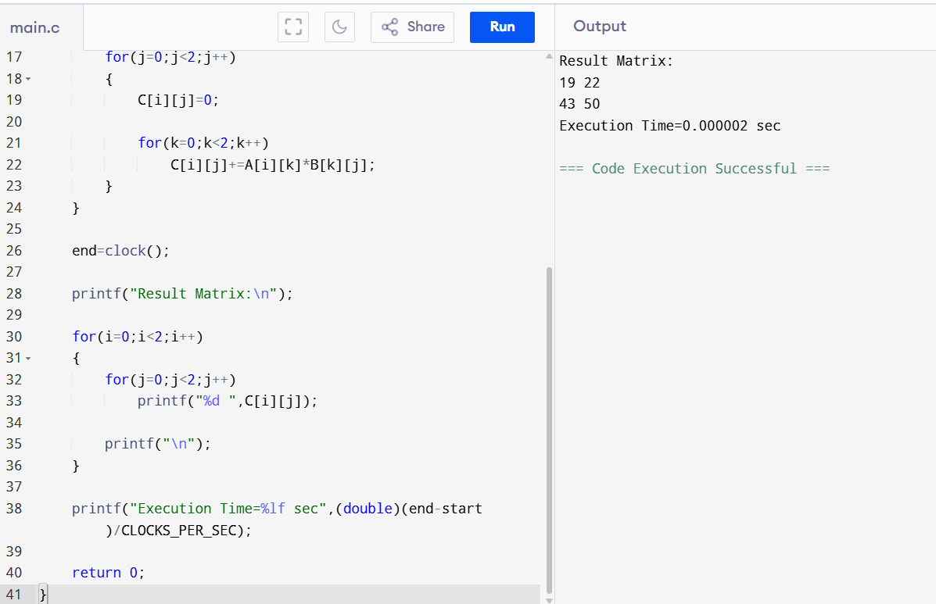

RUBRICS FOR CALCULATION

Experiments
Criteria | Weightage | Level 4 – Exemplary | Level 3 – Proficient | Level 2 – Developing | Level 1 – Beginning
Understanding of Concepts | 25 | Demonstrates thorough understanding and effectively integrates multiple concepts/technologies | Good understanding with proper integration of most concepts | Basic understanding; limited or partial integration | Poor understanding; unable to integrate concepts
Experimental Design | 30 | Well-planned, systematic implementation with optimal solution | Correct implementation with minor issues | Basic implementation with errors or inefficiencies | Incorrect or incomplete implementation
Use of Tools | 20 | Effective and advanced use of tools/technologies with proper configuration | Appropriate use of tools with correct execution | Limited or inconsistent use of tools | Incorrect or minimal use of tools
Analysis of Results | 15 | Insightful analysis with accurate interpretation and validation of results | Good analysis with reasonable interpretation | Basic analysis with limited insights | Poor or incorrect analysis of results
Documentation | 10 | Clear, well-structured documentation with diagrams, code, and results | Organized documentation with necessary details | Basic documentation with missing details | Poor or incomplete documentation

